Boe-Boe Kit Inventory
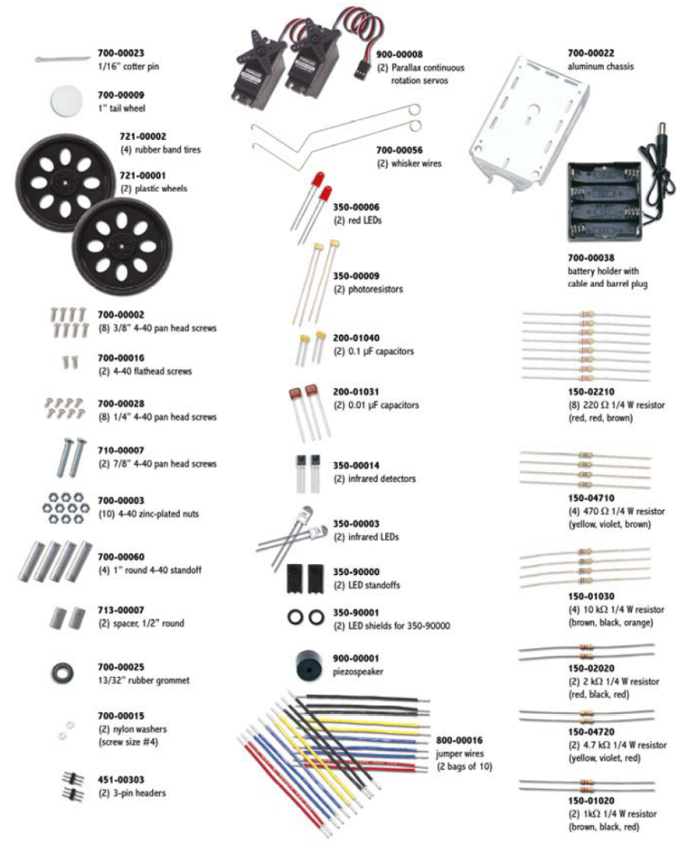

Start of Semester Inventory

Stock Code Description Expected Quantity # Found # Needed

150-01020 1 kOhm resistor 2

150-01030 10 kOhm resistor 2

150-02020 2 kOhm resistor 2

150-02210 220 Ohm resistor 8

150-04710 470 Ohm resistor 4

150-04720 4.7 kOhm resistor 2

200-01031 0.01 micro F capacitor 2

200-01040 0.1 micro F capacitor 2

350-00003 Infrared LED 2

350-00006 Red LED 2

350-00009 Photoresistors 2

350-00014 Infrared receiver 2

350-90000 LED standoff for IR LED 2

350-00001 LED light shield for IR LED 2

451-00303 3-Pin Header 2

700-00056 Whisker wire 2

700-00015 #4 screw-size nylon washer 2

710-00007 7/8” 4-40 pan-head screw, Phillips 2

713-00007 ½” Spacer, aluminum, #4 round 2

800-00016 Jumper wires (bag of 10) 2

900-00001 Piezospeaker 1

400-00002 Pushbuttons 2

201-01080 1000 micro F capacitor 1

28133 Boe-Bot Hardware Pack 1

Robotics Manual 1

Basic Stamp Manual 1

Other parts not listed above:

EGM 180 Student Agreement to Maintain Boe-Bot Kit

I agree to return the Boe-Bot kit with all of the components indicated above at the end of the semester or pay the replacements costs for the missing components.

Signature_______________________________________________________

