Exercise 12: The Basic Stamp and Pololu DC Motor Controller

In this exercise, you will use the Basic Stamp to control two DC motors from the Lego Mindstorms kit using the Pololu serial motor controller.

The completed assembly for this exercise should look something like that shown in the figure below. Note that, as shown below, you may replace your 6 V power supply with a 9 V supply, but this is not required.
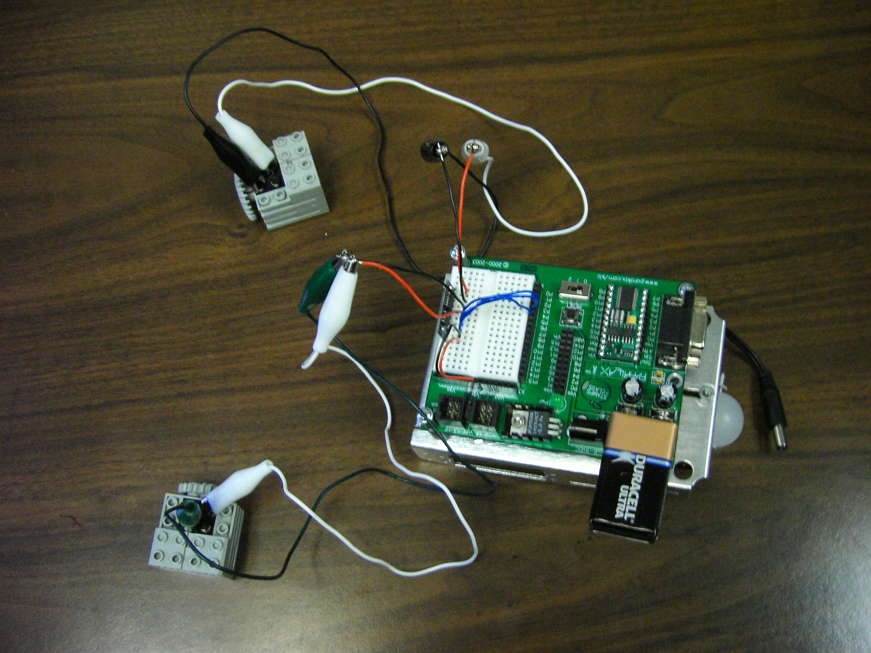

Step 1. Obtain your serial DC motor controller and follow the instructions in the User’s Guide to mount the motor controller on your breadboard and connect it to both the Basic Stamp and the Lego motors. The motor controller connections are indicated on page 2 of the users guide. In making these connections, please note the following.
1. Connect Vin, as opposed to Vdd, to the motor supply (pin 1) of the controller.
2. The logic supply, pin 3 of the controller, can be connected to Vdd or to any of the Basic Stamp pins. If you don’t use Vdd, the pin you choose to connect to the logic supply will enable the controller when set high.
3. The serial control input, pin 4 of the controller, can be connected to any of the Basic Stamp pins. The pin you choose to connect to the serial control input will be used as the serial I/O pin.
4. Reset, pin 5 of the controller, can also be connected to any of the Basic Stamp pins. The pin you choose to connect to reset will be used to reset the controller’s state.

Step 2. Configuring your motor controller by running the following program. Once your controller is configured, it should hold that configuration indefinitely. You should only need to configure it again to change the configuration.

'{$STAMP BS2}
'{$PBASIC 2.5}
HIGH 3 ‘set logic supply to high if not connected to Vdd
LOW 5 ‘reset motor controller
HIGH 5
PAUSE 100 ‘motor controller startup time
SEROUT 4, 84, [$80, 2, %00000001] 'configure controller

In this program, the following connections are assumed between the Basic Stamp and the motor controller. If you have used different connections, adjust the program accordingly.

Basic Stamp Pin Motor Controller Pin and Function
3 3, logic supply
4 4, serial input control
5 5, reset

The program above configures the motor controller for two motors with assigned numbers 0 and 1. Read the section entitled “Configuring the Motor Controller” and answer question 1 of this exercise before continuing. Note that the “new setting” byte is specified in binary.

Step 3. Use the motor controller to control your Lego motors by modifying and running the example Basic Stamp II program from the users manual. The code below is a modification of that program, feel free to use it. Note that the “motor number and direction” byte is specified in binary.

' {$STAMP BS2}
' {$PBASIC 2.5}
speed VAR Byte

HIGH 3 ‘set logic supply pin to high
HIGH 4 ‘take serial line high
LOW 5 ‘reset motor controller
HIGH 5
PAUSE 100 ‘motor controller startup time

FOR speed = 0 TO 127 ‘ramp up motor 0
SEROUT 4, 84, [$80, 0, %00000001, speed]
PAUSE 20
NEXT
FOR speed = 127 TO 0 ‘ramp down motor 0
SEROUT 4, 84, [$80, 0, %00000001, speed]
PAUSE 20
NEXT
FOR speed = 0 TO 127 ‘ramp up motor 1
SEROUT 4, 84, [$80, 0, %00000011, speed]
PAUSE 20
NEXT
FOR speed = 127 TO 0 ‘ramp up motor 1
SEROUT 4, 84, [$80, 0, %00000011, speed]
PAUSE 20
NEXT
END

Note that the following modifications may be necessary:
1. If the logic supply is connected to Vdd, remove line “HIGH 3”
2. The Basic Stamp pin connections to reset and serial control input must match those specified in the program.
3. The motor numbers must match those set when configuring the motor controller.

Step 4: Combining configuration and control: Although it is not necessary to re-configure your motor controller each time you use it, doing so does not hurt and does serve to verify the configuration. The program below can be used to both configure and send speed control commands with your motor controller. Note that the caveats regarding pin numbers mentioned above, also hold for the program below.

'{$STAMP BS2}
'{$PBASIC 2.5}

speed VAR Byte

HIGH 3 ‘set logic supply pin to high if not connected to Vdd
LOW 5 ‘reset motor controller
HIGH 5
PAUSE 100 ‘motor controller startup time
SEROUT 4, 84, [$80, 2, %00000001] 'configure controller
PAUSE 100 ‘DO NOT OMIT THIS COMMAND

LOW 5 ‘reset motor controller
HIGH 5
PAUSE 100 ‘motor controller startup time

FOR speed = 0 TO 127 ‘ramp up motor 0
SEROUT 4, 84, [$80, 0, %00000001, speed]
PAUSE 20
NEXT
FOR speed = 127 TO 0 ‘ramp down motor 0
SEROUT 4, 84, [$80, 0, %00000001, speed]
PAUSE 20
NEXT
FOR speed = 0 TO 127 ‘ramp up motor 1
SEROUT 4, 84, [$80, 0, %00000011, speed]
PAUSE 20
NEXT
FOR speed = 127 TO 0 ‘ramp down motor 1
SEROUT 4, 84, [$80, 0, %00000011, speed]
PAUSE 20
NEXT
END

Questions:

1. Write the SEROUT command that will configure the motor controller to control a single motor with the assigned number 2.

2. How many different speed levels does the motor controller provide?

3. Modify the command below to drive motor number 1 in reverse at speed level 125.
SEROUT 4,84,[$80, 0, 0, 10]

4. What is the PWM frequency used by the motor controller in your setup?

5. Describe the effect of the following program---how will the motors respond?
' {$STAMP BS2}
' {$PBASIC 2.5}

SEROUT 4, 84, [$80, 0, 0, %00000011]
beginAgain:
PAUSE 100
GOTO beginAgain
END

Describe the effect of the program if the beginAgain loop is omitted.

