JEM-171 Pictorial Sketching Exercises
Convert these orthographic views to cabinet oblique:

Convert these orthographic views to isometric:
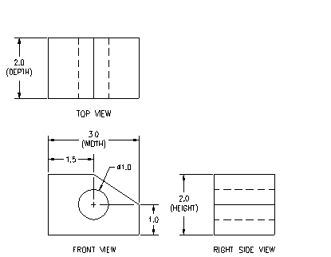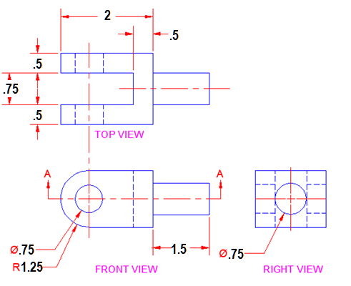
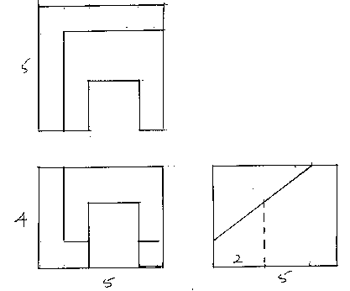
Convert 5 of the first 10 and 5 of the 2nd 10 to 3-view orthographic:
Note: Be sure to include hidden lines where needed!
