Final Project: Impress Your Professor

Context
As your first semester at UNC Asheville draws to a close, it’s only natural that you might be feeling a bit pressured and disillusioned. Perhaps college is not quite what you expected it to be.

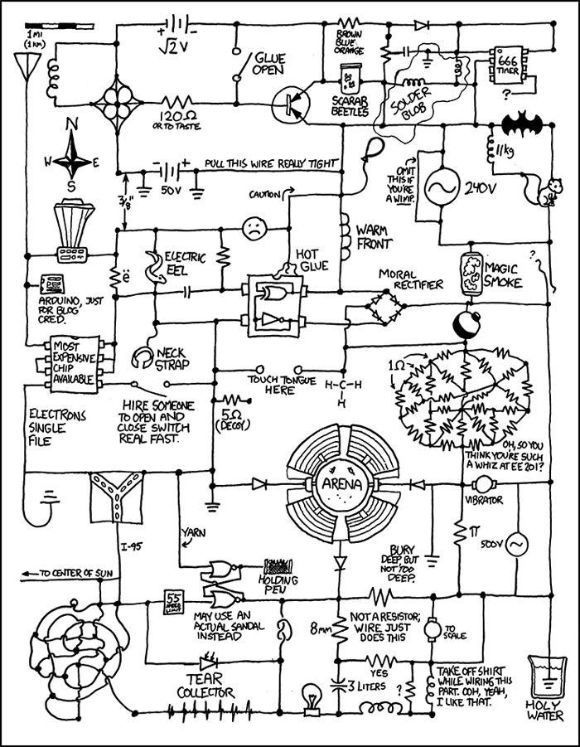But don’t despair; this is your chance to express your pent-up frustrations by creating something evil.
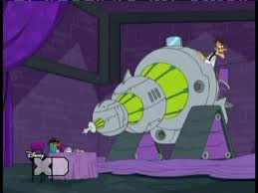
The Turn-Everything-Evil-Inator

Well, maybe not that evil, but at least something mildly evil.

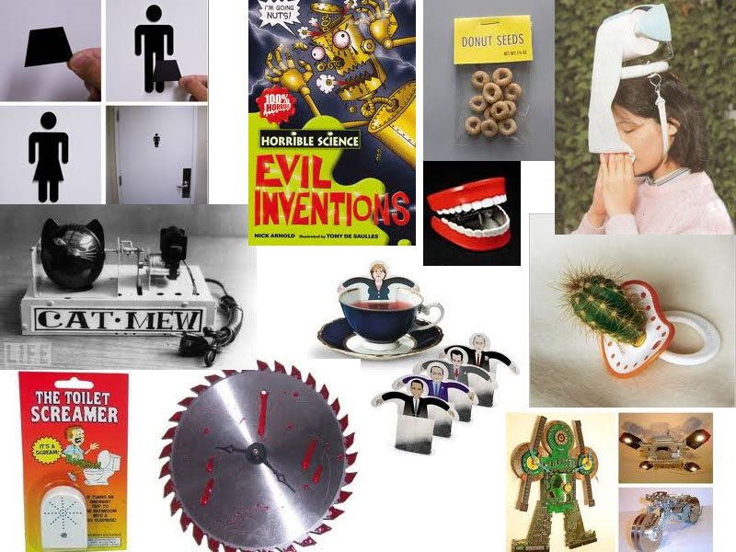

Overview
The objective of this class has been to involve you in the creative use of technology, and this project is the culmination of that effort. In this project, you will have the opportunity to exercise all that we have learned this semester. Your design presentation will require 3D modeling skills as well as writing skills, and your creation itself will draw on our work with electronics and the Arduino.

In this project, you are asked to use what you have learned to create something evil. As is the case for real-life evil scientists, you will need to write a design brief discussing the motivations, rationale, and principles underlying your design. Your design must also adhere to constraints, and be evaluated according to predefined criteria. Sigh…

Design Brief
A design brief is a written plan that describes the objectives of a design, and how it satisfies its criteria, and meets its constraints. A design brief is used to encourage thinking about all aspects of a design before attempting to create it. The elements that must be included in your design brief are listed below; make sure that your composition addresses all of these points.

In this writing assignment, you do not need to organize your composition around a single thesis statement presented in the first paragraph. Instead, you may use separate section headings for each major bullet below, but you must adhere to the writing standards used throughout the semester. Specifically, there must be unity and coherence in the structure of each section and its organization into paragraphs, and you must also strive to use clear and concise wording.

- What evil effect are you are hoping to achieve
  - What activities do you hope to impact
- Existing approaches
  - What’s already out there, evil or benign, that performs the same function
  - How have existing approaches informed your work
  - How and why is your evil design better or different
- Design principles/rationale
  - What guides your design
    - Examples: perpetrate evilness on family and friends, provide self-entertainment at the expense of others, perform some (perhaps un-necessary) function
- Design
  - Describe your design and include a sketch created using Google SketchUp
    - Illustrate and list key features
  - How will you meet the design constraints
  - How will you satisfy the design criteria
  - Design process: how will your design evolve/develop to completion
    - Describe your incremental development and test plan
- Scenarios
  - Provide a concrete example (or two) of how your design is used
- Evaluation
  - How novel is your design?
  - How evil is your design?
  - How functional/nonfunctional and aesthetically pleasing/displeasing is your design?
  - What will you learn as you build it?
  - How will you test it?
- Future directions
  - Suggest possible next steps exist for your project

Design Constraints
A design constraint is a limitation on the conditions under which a design is developed, or on the requirements of that design. In this project, we have both types of constraints.

Limitations on the design development:
- You may use any of the materials provided in class:
  - Arduino boards
  - Breadboards
  - Wires
  - Components (e.g., relays, motor, speakers, sensors, LEDs, switches, etc.)
  - Stuffies, toys, and dolls (donated by my daughter)
  - Construction paper (donated by my daughter)
  - Paints and glues
  - Sewing kits
- You may spend no more than $10 on materials that you acquired outside of class

Design Requirements
Our in-class projects have demonstrated the “functions” listed below. Each function is given a complexity rating. Your final design must have a cumulative complexity rating of 4 or higher. This can be accomplished by incorporating multiple functions and/or multiple instances of a single function. (Note: You can not gain additional complexity points by reading or writing multiple messages on the serial port, or by playing multiple songs on the speaker.)
- Flashing an LED: (1) without Arduino; (2) with Arduino (complexity rating 1)
- Using a switch: (1) without Arduino; (2) with Arduino (complexity rating 1)
- Using a potentiometer: (1) without Arduino; (2) with Arduino (complexity rating 1)
- Using a motor (complexity rating 1)
- Writing and reading from the serial port (complexity rating 1)
- Using PWM to control the brightness of a LED (complexity rating 2)
- Circuit bending (complexity rating 2)
- Using a relay (complexity rating 2)
- Using a single light sensor (complexity rating 2)
- Using a distance sensor (complexity rating 2)
- Playing music on a speaker (complexity rating 2)
If you are interested, there are exercises (that we have not worked) available for the following:
- Sending and receiving infrared light (IR) signals (complexity rating 3)
- Controlling a servo (complexity rating 3)

Design Criteria
Design criteria are the explicit goals that a design must achieve in order to be successful. In this project, the design criteria are also the grading criteria; they are listed below. You must describe how your design satisfies these criteria both in your design brief and during the demonstration of your design on the day of our final.

Technical complexity (40%):
- Your design must be distinct from any single in-class exercise. It should be a composite of functions discussed in different exercises.
- Your design must satisfy the design constraints.
- Design complexity ratings over 4 will be awarded extra points.
Aesthetics (20%)
- Your design must be visually interesting.
- Its appearance must be consistent with its function.
Originality (20%)
- Your design must be distinct from any other design in the class.
- There should be some aspect of your design that is completely original.
Functionality (20%)
- Your design must perform some function consistently and without error.

Due Dates
Design Brief: Dec 6 by the end of class (Our last class meeting.)
Demo of Completed Design: Dec 10 at 11:30AM (Our designated final exam time.)

Grading
Design Brief: 20 points
Completed Design: 25 points

Helpful Hints
If you stuck for ideas, check out the Arduino examples on these electronic resources:

Arduino Playground
Instructables
Makezine
Tod Kurt’s spooky Arduino
Tod Kurt’s Bionic Arduino
YouTube

